Please complete the federal income tax return for Magdalena Schmitz for the tax year 2019. Please complete Form 1040 in its
Entirety (down to the amount owed or the amount to be refunded) and Schedule A. Please complete a handwritten Schedule D, with
The remainder of the supporting calculations. You do not need to complete a formal Schedule D. Please show all calculations on a
Separate piece of paper and document the calculation of the tax liability in the space immediately below these instructions (in the
Space, where indicated); you must use this box to show your calculation of the tax liability or you will not earn credit on this portion
Of the assignment.

Please order the pages of your submission in the following order:
1. This page
2. The Fact Pattern page
3. Form 1040 page 1
4. Form 1040 page 2
5. Schedules 1, 2 and 3, where applicable
6. Schedule A
7. Pages with supporting calculations with reference to the related item being calculated. Calculations without reference will
Not receive partial credit.
Fact pattern page

Magdalena Schmitz has undergone some major changes in her life recently. In 2016, at the age of 46, her husband, Roger, passed away. Magdalena has not remarried as of the end of 2018. Magdalena currently lives on a naval air base as a naval officer. She was living in Pittsburgh when her husband passed away, but she moved back to her childhood home so she could get help from her family raising her children. Magdalena has three children (ages as of the end of the year): Alyssa (23), Tyler (16), and Connor (11). Magdalena reported the following information:
• Magdalena’s social security number is 294-83-2845
• Alyssa’s social security number is 824-84-8456
• Tyler’s social security number is 824-34-9584
• Connor’s social security number is 824-56-2984

Alyssa is unmarried and a full-time graduate student at Pennsylvania State University (PSU) (EIN 33-9876543). PSU’s address is 1250 Happy Valley, State College, PA 16801. She received her bachelor’s degree the year her father passed away, 2016. Alyssa works part-time in State College to help with some of her living expenses and started graduate school. Alyssa earned $2,300 in gross income during the year and had her income tax return prepared on campus by Volunteer Income Tax Assistance (VITA) volunteers. Magdalena provided support for Alyssa including paying for rent, books, tuition, food, clothes, medicine, and other support items. In total, Magdalena provided $12,700 of support for the year. PSU provided Alyssa with a Form 1098-T at year end.
Alyssa’s higher education expenses for her university studies were as follows: Tuition $6,500 Books $2,000
In order to permit Magdalena to maintain a full-time job, she sends Connor to a day care program after school five days a week. During the year, Magdalena paid the day care operator $4,250 for Connor’s care. Magdalena incurred the following moving-related expenses during the year: Transport of household items $3,200 Meals in transit 150 House hunting trip 1,350
In addition, she drove her car the 400 miles to the naval base as part of the move.
Magdalena’s W-2s for the year reported the following: Gross Wages Federal Income Tax Withholding State Income Tax Withholding $48,435 $900 $700 Magdalena’s employer withheld all applicable and appropriate payroll taxes. The entire Schmitz family was covered by minimum essential health insurance during each month in 2018. The insurance was provided by Magdalena’s
Magdalena also received the following during the year: Life Insurance Payment-Mutual Life (Mother’s passing) $150,000 Cash gift from her father $ 5,000 Interest income-First Bank of Bedford $ 310 Interest income-General Electric Bond $ 3,200 Interest income from U.S. Treasury Bond $ 350 Interest income-Bedford School District Municipal Bond $ 2,500 Interest income-Johnstown Rural Improvement District Bond $ 1,300 (municipal interest income) Qualified dividend income from Abbott Labs $275 Qualified dividend income from 3M $350 Dividend income (not qualified) from China Fund $2,000 PA state income tax refund* $ 325 *Refund was from state tax she paid last year. Magdalena deducted all of her state taxes as itemized deductions, and received full tax benefit for the deductions, on her prior year federal tax return. Magdalena paid or incurred the following expenses during the year: Dentist (unreimbursed by insurance) $6,500 Doctors (unreimbursed by insurance) $4,475 Prescriptions (unreimbursed by insurance) $ 255 Real property taxes on residence $7,950 Mortgage interest on principal residence (Form 1098 received) $9,845 Contribution of stock to the American Lung Association $ 600 Basis; FMV at date of donation $800. Long-term Contribution of land to the Habitat for Humanity $10,000 Basis; FM
Magdalena had the following activity in their brokerage account during the year (all transactions were reported on a Form 1099-B. Basis information on each stock sale was reported to the IRS): Sold 2,000 shares of Microsoft 7/1/18 $22,500 Sold 75 shares of Apple, Inc. 4/15/18 $28,750 Sold 350 shares of Cooper Tire 10/14/18 $14,700 Sold 1,000 shares of Cardinal Health 11/10/18 $3,500 Relevant tax basis/holding period information related to sales of securities in the current year: Purchased 2,000 shares of Microsoft on 8/1/17 for $21,000 Purchased 200 shares of Apple, Inc. on 3/8/14 for $40,000 Purchased 350 shares of Cooper Tire on 1/12/13 for $9,000 Received 1,000 shares of Cardinal Health from Magdalena’s father as a gift on 10/10/00. Her father’s basis in the stock at the time of the gift was $7,000. Fair market value of the stock at the date of the gift was $5,000 Magdalena has a $3,000 long-term capital loss carryover from the prior tax year.

Form 1040 page 1
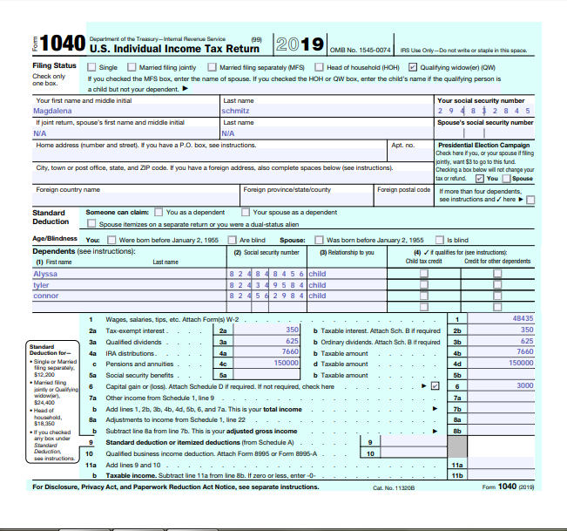

Form 1040 page 2
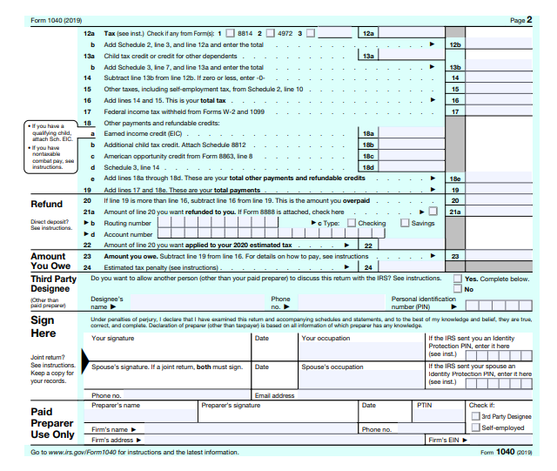

Notes
-Magdalena's eligible to use qualifying widow (err) with dependent child as filing status for 2 years following the year your spouse died. Her spouse died in the year of 2014.Magdalena has not remarried as of the end of 2016.

-Magdalena's federal income tax under the filing status is Qualifying Widow (err) with Dependent Child.

-Magdalena can’t claim alyssums higher education expenses for her university studies because Alyssa itself filling tax return.

-Magdalena paid the day care operator $4,250 for Connors care, Magdalena's total expenses Connors care, may use to the credit should not be more than $3,000= $$4,250 - $3,000 = $1,250.

-Magdalena incurred moving-related expenses not having exemption because her change was not related with job (because her main reason is pursue a life and then only start her new job. =$8050

-She drove her car the 100 miles to Bedford as part of the move, she can claim up to 23.5 cents per miles,
Totally she can claim up to =$2,350.

-Magdalena’s employers withheld all applicable and appropriate payroll taxes so can’t claim exemption from withholding for the current year, because she does not qualify from any one reason mentioned below for claim.

-If Magdalena claims exemption from withholding, her employer will not withhold federal income tax from wages.

-For the prior year, Magdalena? Had a right to a refund of all federal income tax withheld because she had no tax liability.

-For the current year, Magdalena? Expect a refund of all federal income tax withheld because her expect to have no tax liability.

TAX COMPUTATION OF MAGDALENA FOR 2019 | Amount (in $)
Income from salary: | 48435
Income from other sources
Interest income-First Bank of Bedford | 310
Interest income-General Electric Bond | 3200
Interest income-Johnstown Rural Improvement District Bond | 1300
PA state income tax refund | 325
Net income from other sources | 5135
Exempt Income: (for reporting purpose only)
Interest income-Bedford School District Municipal Bond | 2500
Interest income-from Treasury Bond | 350
Cash gift from father | 5000
Life Insurance Payment-Mutual Life (Mother’s passing) | 150000
Gross total income | 53570
Less: Qualified divided income from Abbott Labs | 275
Less: Qualified divided income from 3M | 350
Less: Dividend income from China fund | 2000
 | 50945
Add: sold 2000 shares on Microsoft | 22500
Add:sold 350 shares of Cooper Tire | 14700
Add:sold 1000 shares of Cardinal Health | 3500
Add:sold 75 shares of apple,Inc | 28750
Add (900+700+7000+5000) | 13600
 | 133995
Less:Expense
Dentist (unreimbursed by insurance) | 6500
Doctors (unreimbursed by insurance) | 4475
Prescriptions (unreimbursed by insurance) | 255
Real property taxes on residence | 7950
Mortgage interest on principal residence (Form 1098 received) | 9845
Contribution to the American Lung Association | 1400
Contribution to the Habitat for Humanity | 25000
Alyssa Expense | 12700
Day care Expense (Connor ) | 1250
Moving Expenses | 4700
 | 59920
Less capital loss | 3000
Total | 56920

